CL/BSCSD/19/82 / st20171735

Mohammed Niaz Mohammed Inzamam

Advanced Student Information System with Student Guiding and Recommendation and Results Prediction System for Greendale College to Enhance Student Performance

# 

Interim Report

# Chapter 01

# Introduction

Technology is widely used in present and people are used to live with it. However, some web applications are too old to run parallel with todays. The schools and education nowadays also already changed. For not only Universities and high school, primary school also must have their own management systems. However, the current management system of Greendale College is already defined as old generation management system and it already cannot satisfy the users

As a result, a system called Greendale College Student Information System will be developing as an upgrade version of the old system or to replace manual system to solve problem that facing when was using the old system or manual system. Advanced student information system with student guiding and recommendation system for Greendale College is a software application for education that use to managed students information and data.

This design of this system is web-based type, so the user also can directly use the system by connecting to the internet. The users of this system are given to two groups, which are administrators and students. The functions of administrators are read, write and edit. Through this system, administrators can manage all student data and information easily and the students can easily know their performance easily.

Besides that, this system added new technologies for automatically give recommendations and Guides for students and predict students future results using their past result to improve their college course work. In order to do that system use students past result for their each subjects and system will automatically give recommendations and prediction of upcoming subject results to improve student’s results in exams and assignments in their course work.

This new system will replace the current system that is used in Greendale College and surely, this system will improve the student management system of the college and efficiency of the job.

# Problem Statement

Using manual system to manage the students which are records all information and in the book or paper was causing the job of the lecturers becomes more and troublesome. The record in the have a possibility missing or destroy when happen any accident. While now already have the university use the computer to manage the student information, but both of the systems they use are already out dated system. The system they use all are standalone and separately, one system only have one function. This was cause lecturers harder to use all the system on the same time. The separately system without connection with each other also cause the same data and information the needed key in in every system. Besides that, the system that using also does not have the result predicting feature or a student recommendation and guiding system. This will cause the student will get less marks for future assignments and the exams and student would not motivate for their university studies and works.

# Solution

Introducing full-automated Advanced Student Information System for Greendale College with Student Guiding and Recommendation and Result Prediction System to Enhance Students Performance. This system would make administration to do their job easily through the system. In this student management system admin, students all user levels have different new functionalities. Students can download and submit their assignments, view their payments, results, make complains, get notices and notifications from university can be do through the system, administrators can manage all the data of the student and the lecturers through this system and also store student date and information.

Failed in test or scores dropped are causing the student were scared and less marks made their grade low and sometimes fail their subjects but using new function to predict future results of the students make themselves to study hard to improve their performance and students can also see their performance. Every students learning ability are different, some of them are good, some of them weak. So the results that gets also different. As student if they got recommendations to for their results students also try hard to make themselves to study to improve their results according to the recommendation they got via the system. This recommendation system will make student motivate for their course work and make good performance in their grades.

# Functionalities and Non-Functionalities of the system

## Admins main functionalities

* Login
* administrator must login to the system first. he can login using by user name and password
* admin have to use the correct password incorrect username and he can login to system directly
* if administrator going to using the incorrect password and username he can see the error message on the top of screen.
* Register
* administrator cannot register the system. because he has a username and password in the database
* Enrol Students
* Admin can register students and also he can update the student’s records and details.
* Manage Users
* Admin can add users to the system also he can manage users details and he or she can update the user details also he can register a student to the system.
* Manage Profiles
* Admin can manage the user’s records and details.
* Manage Students
* Administrators should have permission to update the students results and students assignments marks and there details
* Manage Courses
  + - administrator can add courses to the system and he can also update the course details and remove the courses from the systems
* Manage Fees
* administrator can update the course fee and another course fee to the system
* Manage Results
* administrator can and student’s assignments and exams results to the system and he can also update the student’s results
* Manage Assignments
* administrator can add assignment to the system and he can also remove the assignment from the system and update the assignment details
* Reply for Complains
* admin can view complaints and reply for it

## Admins main functionalities

* Login
* Students should be given the ability to log in to the system by id as the user name and the password.
* With using own id and pass word. Students will be allowed to login in to the system.
* View future results predictions
* student can view their future results prediction in the system
* View Recommendations and Guiding
* system will be automatically send the guiding and Recommendation messages from the system
* View payments
* Students can view their payments information on the system
* View Results
* Students can view their Results information on the system
* Submit and download assignments
* students can download the assignments and view their assignments and also he can upload to upload their assignments to system
* Make Complains
  + student can make a complaint

## Non functional requirements

* performance
* students can easily work with the systems because the system can manage lot of users at the same time.
* Security

# Chapter 02 - Literature Review

## Literature Review

For the last few years, researchers are working to address the issue of student result analysis and prediction. In Mining Educational Data to Analyse Students Performance is a decision tree-based classification technique to predict students’ final exam results has presented. The authors stated that educational databases’ hidden information could play a vital role in students’ performance development (B. K. Baradwaj, S. Pal,, 2011).

Surjeet Kumar Yadav and Saurab Pal in Data Mining Application in Enrolment Management Proposed a data mining approach to predict good students to enroll in the Master of Computer Application (MCA) course in India using their past academic records. They conclude that Bachelor of Computer Application (BCA) and B.Sc. Students with mathematics performed better in the MCA course, and B.A. Without mathematics did not perform well for the course (S. K. Yadav, S. Pal, 2012).

Cristobal Romero ET. Al Data Mining Algorithms to Classify Students Classify Students Collected real data of seven Moodle courses from Cordoba University students to develop a specific Moodle data mining tool. The authors compared different data mining techniques to classify students based on their Moodle usage data and the final marks obtained in their respective courses. The authors concluded that a classifier for educational decision making should be both comprehensive and accurate (C. Romero, S. Ventura, P. G. Espejo, C. Hervás, 2008).

Lewis Adam Whitley’s Educational data mining and its uses to predict the most prosperous learning environment research to predict the most affluent learning environment. Within this research project, the author would attempt to use data from the University of North Carolina at Pembroke and process the data into environmental factors that may or may not influence a student’s learning ability. The author determined the best method in order to seek a learning environment and try to discover the factors that could impact on a student’s academic performance (Whitley, 2018).

Authors of A Data Mining System for Predicting University Students’ Graduation Grades Using ID3 Decision Tree Algorithm analysed a system that will predict student’s grades using the ID3 decision tree algorithm, where data gathered from the academic department of Redeemer’s University, Nigeria (A. O. Ogunde, D. A. Ajibade, 2014).

predict students

Gopichand A study on Implementation of classification techniques to predict students presents the implementation of different classification techniques for vocational institutional analysis that help teachers to work on weak students to improve their performance and claimed that decision tree is the accurate prediction model for institutions students’ analysis (Gorikhan, 2016).

Bhardwaj and Pal A prediction for performance improvement using classification conducted another study on predicting the students’ performance by choosing 300 students from 5- degree college conducting BCA (Bachelor of Computer Application) course in Dr. R. M. L. Awadh University, Faizabad, India. Using the Bayesian classification technique on 17 attributes, they showed that students’ academic performance relates to both the academic and non-academic attributes like family annual income and students’ family status, etc. This study would help the students to improve their performance. This study would also help to identify those students who needed special attention and by taking appropriate action at the right time the fail ratio could also be reduced. However, specific suggestions to overcome the lacking were absent in the study. So, more works need to done to find more effective solutions for university students’ result analysis and prediction systems, especially in Bangladesh (B. K. Bhardwaj, S. Pal, 2011).

SPA is existing secure online web-based software that enables educators to view the students’ performance and keep track of the school’s data. The SPA is a tool designed for analysing, displaying, storing, and getting feedback of student assessment data. It is a powerful analyser tool used by schools worldwide to perform analysis and displays the analysis data once raw student data is uploaded to the system. The analysis is done by tracking the student or class to get the overall performance of student or class. It helps to identify the students’ performance, which is below the expected level, at expected level or above the expected level. This would allow the educators or staffs to identify the current students’ performance easily. Other than that, it enables various kinds of students’ performance report such as progress report and achievement report to be generated. (Chew Li Sa, Dayang Hanani bt. Abang Ibrahim, Emmy Dahliana Hossain, Mohammad bin Hossin, 2014)

Professor Krithi and Dr M Ramakrishna explains in International Research Journal of Computer Science in 2017 about this (SIRS) in this Student Information Report System (SIRS) the system has come up with many functionalities for educational institutions to track the student progress and performance and managing attendance. It helps both student and guardian to keep track of student progress without visiting to the college. It also notifies student and guardian during the time of important events, which are happening in institution. One more feature is guardian be alerted whenever student is failed in the exam or student not able to meet the expected attendance average. Student Information Report System (SIRS) is application software and which has intention to begin a conductive and direct interchanging the statistics in a secure platform to coalesce with students, faculties, parents and the college/school administration. The student information has the particulars (like register number sem, date-of-birth, sex, parent phone number, address, parent name, etc.) invade to the system by the faculties. All these particulars is stored in the database. SIRS application is trouble free to use in schools, colleges, universities, and any other educational institutions. It can be customized as per the need. It can be used in private and government educational institutions also. SIRS application is an internet-based application we can login to the system from anywhere irrespective of geographical area it will give seamless navigation. The paper provides the particulars to carry out the performance, management and decision-making functions of enterprises or organizations. Enormous grow of students is caused to expand the functionality in the respective educational institutions. As student added to the educational system it is difficult to manage and track student details. To overcome difficulties we come up with this new approach student information management system with additional features. This new approach will provide fast processing, efficient student tracking, and produces desired result. This approach will allow students to save their personal details. It is more secure, reliable and easy to use. (Krithi, M Ramakrishna, 2017)

InMinds helps University Malaysia Sarawak (UNIMAS) to monitor the performance of various areas in every UNIMAS’s departments. The system enables top and mid-management in UNIMAS to have a clear look on the areas that needed attention by looking at the figures, revenues and risks. The features, ease of use and flexibility provided by the system makes the performance analysis in UNIMAS to be performed in an ideal solution. Charts are provided by the system for ease of student performance’s interpretation. From the reviews on these existing systems, useful techniques and features could be applied into the proposed system for a better system’s performance. The WEKA is chosen as a tool for data mining because it is open source software. (Ali, 2013)

At the core of every system’s efficiency is the availability of services because very often users rate the whole system performance depending on the satisfaction they get in using such services. To meet users’ needs and expectations, almost every online student management has a myriad of services. For instance, Maere (2011) explains that the SMS handles the administration part of students which includes; admission, examination records, assessment process, finance, room allocation, transcripts, students union electronic voting, mobile text messaging, examination results feedback. Therefore, it is certain that in most institutions of higher learning, online student management systems are created in house to assist in registration of students, student online profiling, financial recording, examination grades records, transcript generation, student accommodation management, and keeping student records (LUBANGA, 2017).

Solution

Introducing full-automated Advanced Student Information System for Greendale College with Student Guiding and Recommendation and Result Prediction System to Enhance Students Performance. This system would make administration to do their job easily through the system. In this student management system admin, students all user levels have different new functionalities. Students can download and submit their assignments, view their payments, results, make complains, get notices and notifications from university can be do through the system, administrators can manage all the data of the student and the lecturers through this system and also store student date and information.

Failed in test or scores dropped are causing the student were scared and less marks made their grade low and sometimes fail their subjects but using new function to predict future results of the students make themselves to study hard to improve their performance and students can also see their performance. Every students learning ability are different, some of them are good, some of them weak. So the results that gets also different. As student if they got recommendations to for their results students also try hard to make themselves to study to improve their results according to the recommendation they got via the system. This recommendation system will make student motivate for their course work and make good performance in their grades.

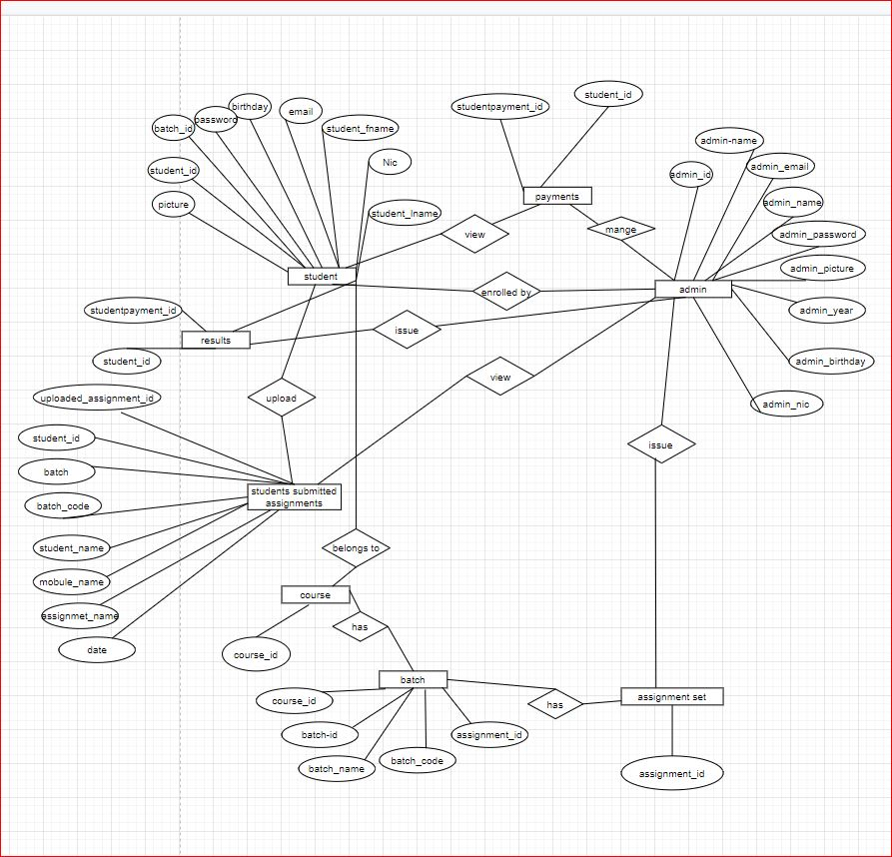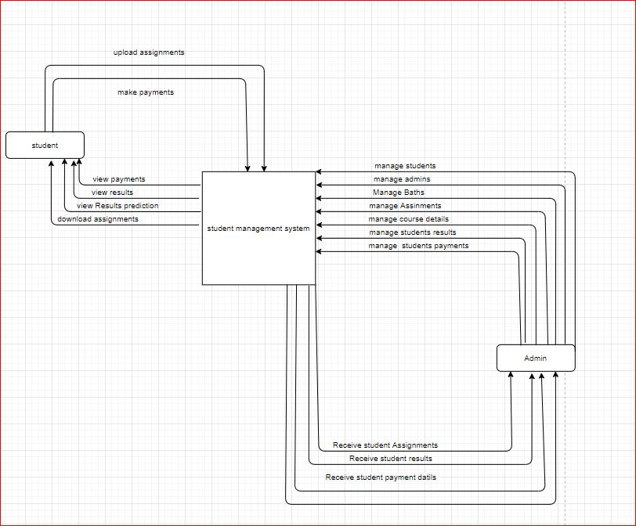

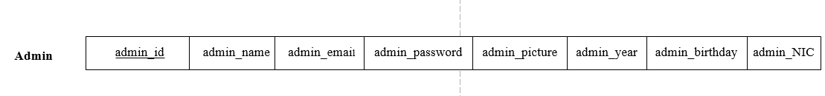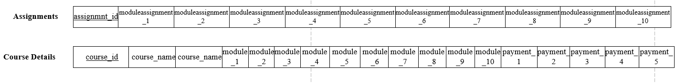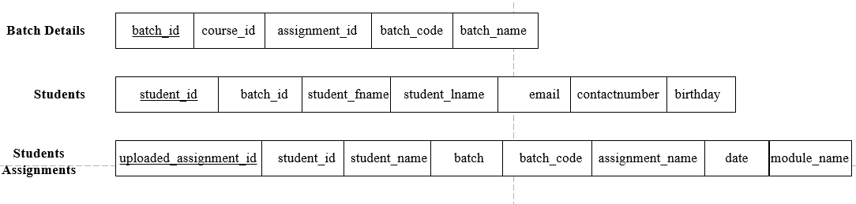

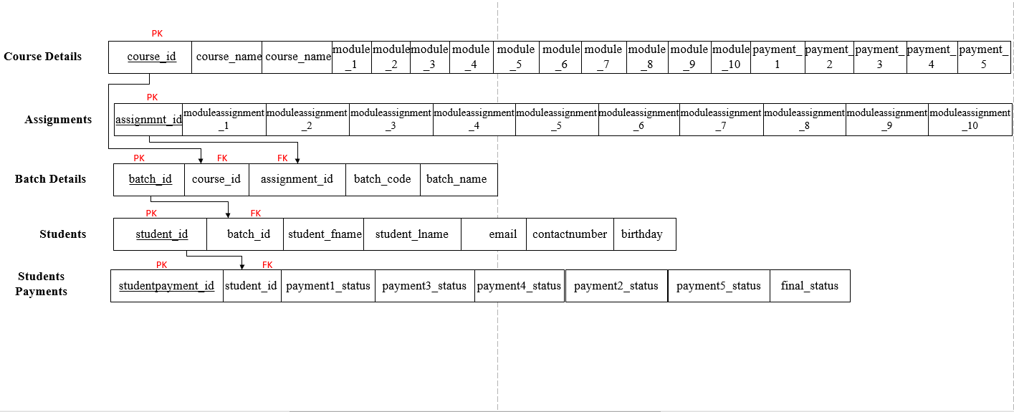

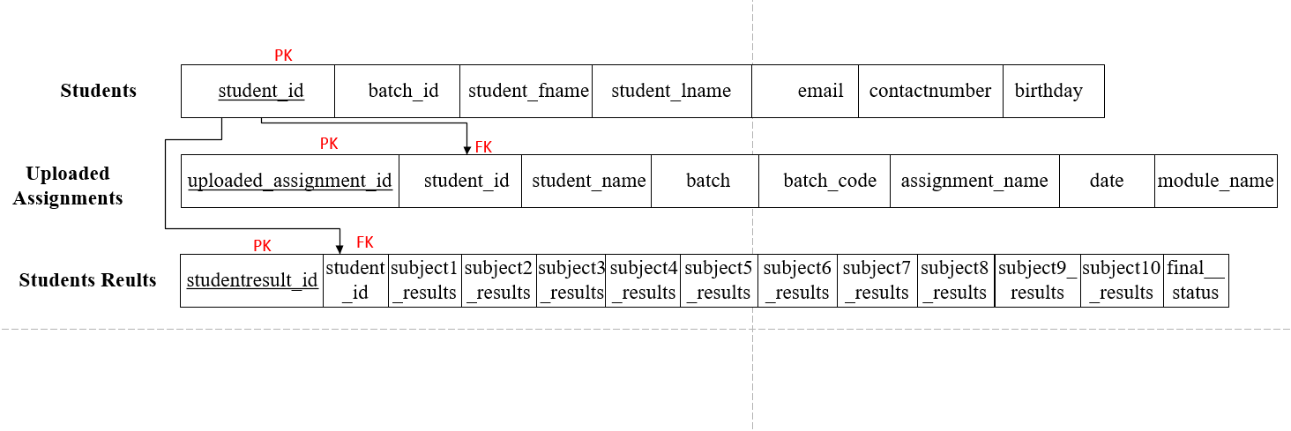STEP 4: MAPPING OF 1: M ENTITIES

Figure 11 - 1: M

STEP 5: MAPPING OF M: M ENTITIES

**NONE**

Data Flow Diagram (DFD)

A visualization of the flow of information within a system is given by the Data Flow Diagram DFD. You can say the information supplied and provided to anyone who participates in system processes by drawing a Data Flow Diagram, the information required to complete the processes and the information needed to be processed and accessed by the data flow diagram.

Context Diagram

A context diagram is a data flow diagram representing only the top level. At this stage, in terms of how it interacts with external entities, there will be only one visible process node which represents the functions of a complete system. Many of a Context Diagram’s usefulness are:

* Displays a description of a system's limits.
* No technical knowledge is necessary to comprehend simple notation.
* Easy as its minimal notation, to draw, change and elaborate.

Level 1

